Elevate Eagle Comprehensive Plan Update (2021)

Background
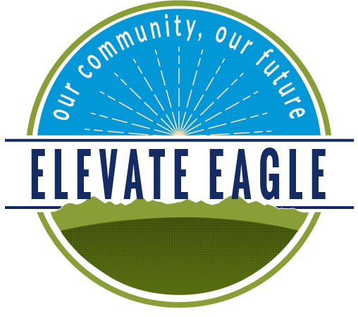
In December 2020, the Town of Eagle adopted the Elevate Eagle Comprehensive Plan (Comp Plan). The Comp Plan is a long-range planning document that acts as a road map for future development and redevelopment within the Town of Eagle. Rather than settling for what is here now, the Comp Plan looks to what the community can be. Within the Comp Plan is the Town’s Future Land Use Map (FLUM) that identifies future land uses within the Town’s Urban Growth Boundary.
Why are we updating a plan that was adopted less than a year ago? The Comp Plan is a dynamic document. As the community changes, the Comp Plan should also change to best reflect the community’s desires and vision.
The adopted 2020 Elevate Eagle Comprehensive Plan can be found on the Town’s website at: https://www.townofeagle.org/DocumentCenter/View/16477/Elevate-Eagle-Comprehensive-Plan_with-Appendix_reduced

Proposed Updates
The purpose of this focused update is to modify land use designations in the FLUM. Specific amendments to the Comp Plan and the FLUM can be accessed through the Town’s ‘Active Land Use Application’ webpage at https://www.townofeagle.org/418/Active-Land-Use-Applications.

Update Process
There are opportunities for you to comment on the proposed changes to the Plan. Please submit your thoughts through email at peyton.heitzman@townofeagle.org or participate at one of the upcoming meetings listed below.

